SRS Document

Submitted to Rahul Marketers
Commodity Intelligence System

Credence Technologies
Hyderabad 500 082
India

Prepared By: | Reviewed By;
P.Sriramachandrudu | N.Rajendra

Table of Contents

Introduction

1.1. Purpose

Scope

Definitions

1.4. References

1.5. Overview

1.6 Project Goal and Objectives

2. Overall Description.

2.1. Project perspective

Project functions

2.3. User characteristics

2.4. Constraints

2.5. Assumptions and Dependencies

Specific Requirement

3.1 External interface requirements

3.1.1. User interfaces
3.1.2. Hard ware interfaces
    - Software interfaces
    - Communication interfaces

3.2 Functional requirements

3.2.1 Information flows
3.2.1.1 First Level Data Flow Diagram
3.2.1.2 UML Diagrams

3.2.2Database Design
3.2.2.1 Table design document

3.2.3Database Creation scripts
3.2.3.1 Database creation script

Introduction

Introduction:

Purpose

In this age of Globalization information is power and the whole world is running for a platform where one can meet the customer mind share and here is a platform that can outpour all needs for what so ever on Commodities. Good business is still sealed with a handshake especially on the Internet, with CIS which is pioneered virtual market place, which can make your business a real business where in one, can proudly say that the agri-world is at their tips and the pricing now rests in their hands.
Commodity Intelligence System (CIS) is a unique concept of networking all the major National Trading Centers / Marketing Yards in India and important state Trading Centers / Market Yards across the length and breadth of the country.

1.2 Scope

The scope of work would include:

To cover the state of Madhya Pradesh out of 32 states and union territories.

To cover about 5 commodities that are selected out of large volume/value commodities dealt in 292 markets.

On successful deployment of the system in Madhya Pradesh i.e. Release 1.0, the same shall be extended to all commodities mounting to 560 approx. in all states of India.

1.3.Definitions

Commodity: Items or Goods of commercial value that are either perishable or non-
perishable, consumable or otherwise.

Information-supplier: A person who supplies information about Commodity Price
& Quantity Data to CIS. This constitutes the main input to
the system.

Location: It is any place specified by a hierarchy of Country, State, District.

Customer: Any person/persons/institution/organization which is interested in
subscribing to CIS information especially commodity-price related
information.

Market: A place where commodities are traded. Each market is specified by a
unique Market ID. This ID is generated by CIS's internal logic. A
market is identified by it's name and place.

  - References
1.IEEE Documents for SRS
2. Software Engineering by Roger S.Pressman

Overview :

It is a portal developed with can be defined as complete solution for the commodity class which envisage a very user friendly platform for all classes which are based on commodity transactions by providing a service for every one interested in picking up commodity prices . It is a unique concept of networking all major national trading centers and market yards across the country providing regularly updated online information about commodity prices at any particular point of time along with all structured reports vis. Trends and projections daily, weekly, monthly, yearly which are the ready recknover for all classes requiring information on commodities.
The main purpose of CIS is essentially to collect the latest fluctuating prices of commodities available and required in the market at a particular given point of time and at particular specified market locations. So that the producer, trader, consumers can get best deal out of their all commodity deals and derive reasonable profit in all levels.

  - Project Goal And Objective :

Is to achieve stability of price, supply and demand of commodity for all related activities.

Assist planning proper production, based on accurate Supply and Demand.

To provide accurate, timely prices and availability (Supply and Demand) of commodities to wide spectrum of society spanning farmers, businessmen, traders and consumers on-line.

- To enact as an excellent end to end business solution for all classes based on commodity trade providing an avenues to explore more business opportunities by navigating through more and more prospective range of buyers and sellers thus having a most competitive edge over all business practices and evoking more profits and reducing all unnecessary overheads.

Complete Information Technology backbone for entire commodity market sector both essential & non-essential businessmen, producers and traders, consumers based on proven emerging technology.

Over all description:

2.1 Product perspective

a). System Interfaces:

The application enables Customer to login directly to Web site from their desktop using a conventional Web browser.

CIS Application is an Internet Application.

CIS is an independent, totally self-contained application runs web server like IIS and on Windows Operating System. This web enabled application works with browser like Internet explorer 5.0 and above at client side.

CIS will be based on Internet architecture and the layout of the application is explained in the following diagram.

Customer 1
Web
Server
IIS 6.0

B
Database
Server
(SQL Server 7)

Info Supplier
B

Customer n

B

Architecture of CIS

A, Customer : Any person/persons/institution/organization which is interested in
subscribing to CIS information especially commodity-price related
information.
Info- Supplier : A person who supplies information about Commodity Price & Quantity Data to CIS. This constitutes the main input to the system.

B. Web Server: The Business Logic / Validations / Security of the CIS will be implemented here.

C. Database Server: The information of the CIS will be stored in the Database Server. It can also be called as Data Services (SQL Server 2005).

b). User interfaces:

This section describes the application with the help of word document proto type screen flow design.

The next few screens explain the navigation of some page of CIS application.

c). Hardware Interfaces

This application is purely Internet Application which runs through HTTP Protocol.

d). Software Interfaces

- Application installed on Web server. Clients can access server through any client by using WEB browser like Internet explorer 5.0 and above.
- Client network should support any network protocol like TCP/IP.
e). Communication interfaces:
For the establishment of Internet following Communication protocols are necessary.
- TCP/IP protocol.
- HTTP protocol.

f). Memory constraints:
There is no constraints on memory related issues. Normal server and client
Configuration is sufficient to run this application.

2.2 Project Functions :

2.2.1) CIS Features

Sno | Feature ID | Description | Remarks
1. | CIS/FS/1. | CIS will network all the major National Trading Centers / Marketing Yards in India (around 8713) and important state Trading Centers / Market Yards across the length and breadth of the country.
2. | CIS/FS/2 | CIS will collect the latest fluctuating prices of commodities available and required in the market at a particular given point of time and at particular specified market locations. This is done on an hourly and daily basis.
3. | CIS/FS/3 | CIS will monitor this facility by setting up a system by which the traders can take the advantage of the fluctuations prices in the commodity market
4. | CIS/FS/4 | Creating Master data for location, commodity, info centers, info suppliers, info seekers, periodic prices (for e.g. hourly, half-hourly) and daily prices of various commodities at various markets.
5. | CIS/FS/5 | Process data, generate service reports on viz., daily current prices of specified commodities in all respective markets, high low prices, weekly, monthly, quarterly prices of commodities in all designated markets
6. | CIS/FS/6 | Generate Price trends for commodities, besides generating MIS reports on operational management.
7. | CIS/FS/7 | Proposed Business process flow  - Collection of Prices and quantity traded in various markets in a prescribed format, to be handed over to the info supplier.  - The data is entered in the computer terminal, transmitted through Internet connectivity to central CIS sever .  The hard copy of the information is also made available along with transmitting the information through telephone, personally, or on Internet to the members.
8. | CIS/FS/8 | Info-supplier:  Associated with every Market are sets of info-suppliers who collect Commodity Information for the markets and feed it to CIS via the Internet periodically (every one hour or at the closing time of the market for the day). An info-supplier is associated with a market (or several markets). An info-supplier is registered on a per-market

CIS 1.0 Functional Specifications

Sno. | Feature ID | Description | Remarks
1. | CIS/FS/001 | CIS Server:  Groups of Functionality:  There are 4 Groups of Functionality to be made available on/from the CIS Server side. A piece of functionality may be accessed either directly on the CIS Server (most cases)i.e. Internet or through some other channel like Email, Fax, Telephone, post, manually etc.  The 3 Groups of Functionality are:  - MASTER  - TRANSACTION  - REPORTS
2. | CIS/FS/002 | MASTER FUNCTIONALITY:  The information specified in the Master is regarded static, in the sense that it is “permanent” or non-changing or stable.  The updates are infrequent and may be regarded as permanently stored in the Database.  The Master Group has functionality to view/change the following data:  - Location  - Commodity  - Market  - Markets at Locations  - Commodity at Markets  - UOM  The information in Master may be changed only through the specified GUI.
3. | CIS/FS/003 | MASTER LEVEL DATA:  Classification of Commodity Data.  All CIS Commodity data shall be stored on the CIS Server side in a Database.  The CIS Data is got as specified in CIS/FS/006.  Each piece of CIS Commodity Data is to be classified on the following bases:  - Commodity (specified by the Commodity Name, its category, Subcategory and Grade).  For e.g.:  Commodity Name = “Grain and Pulses”  Commodity Category = “Rice”  Commodity subcategory = “Musoorie”  Commodity Grade = "Sona-Mussorie"  - Season in which the commodity is available.  - Market (specified by the Market Name)  - Location: This is to be identified on the basis of Country, State, District, Mandal and Village and Street Name. These six together yield a unique Id for identifying the location of any market.  The information specified in the above classification is regarded static, in the sense that it is “permanent” or non-volatile or stable. Each of these has to be specified in CIS before they can be used.
4. | CIS/FS/004 | The TRANSACTION Group of functionality is as follows:  - Commodity Prices (updating)  - Info-Supplier Registration  - Customer Registration  Transactions deal with dynamic or transient data.  Transactions do not affect the MASTER Data.
5. | CIS/FS/005 | TRANSACTION DATA:  CIS Commodity Data:  Contents of Commodity Data:  - Price of Commodity  - Time & Date on which the Commodity Data information was collected  - Market Id (Market at a Location)  - Information-supplier (who supplies information about Commodity Price & Quantity Data to CIS).  Of these contents, the “Price” and “Time/Date” information are of prime interest to CIS and are collected periodically.  Group: Master.  Of the rest of the contents, the “Information-Supplier” part may be treated as quasi-permanent if not “transient”. It is collected only once (not periodically) and is treated as unstable (relative to “static information” of MASTER) because the info-supplier might be replaced or may take on responsibilities for collecting different commodities data as per short-term business requirements. Each Info-supplier is given a unique ID.  The information regarding Price, Quantity and Time/Date specified in the rest of the contents is regarded as dynamic, in the sense that it is “transient” or unstable or varying on an hourly or daily or monthly or even on an unspecified time period basis.
7. | CIS/FS/007 | TRANSACTION DATA:  Info-supplier:  Associated with every Market are sets of info-suppliers who collect Commodity Information for the markets and feed it to CIS via the Internet periodically (every one hour or at the closing time of the market for the day). An info-supplier is associated with a market (or several markets). An info-supplier is registered on a per-market.
8. | CIS/FS/008 | TRANSACTION DATA:  Customer:  A customer is defined as one who is interested in receiving CIS Commodity Information and has registered for it with the CIS. A customer registers thru internet / website with the CIS.  So, a Customer can be registered to Query for specified CIS Information REPORTS to be got from CIS.  NOTE: The Commodity information REPORTS may be sent to a customer (periodically or on demand) through any means or channel (e.g. Fax, email, telephone or even manual). Each customer gets a unique Id. Provision for renewal, priority commodities, lowest price information; communication address and mailing facility are other details of customer.
9. | CIS/FS/009 | The REPORTS Group of Functionality:  This group of functionality causes queries to be invoked on the CIS Database in order to generate various Reports about CIS Commodity Data.  They are:  Examples of Reports:  - Current Price (all markets)  - Daily Prices  - Low/High Prices  - Weekly Prices (on a daily basis)  - Monthly Prices (on a weekly basis)  - Quarterly Prices (on a monthly basis)  - Annual Prices (on a quarterly basis)  - Trend of Prices  - Find
10. | CIS/FS/010 | When the CIS client application is opened for a fresh operation-session at the CIS website, it validates the user (Customer, Info-supplier or Trader ) with a login and password mechanism
11. | CIS/FS/011 | After logging into the CIS Site, the Client operator can perform any of the TRANSACTIONS or query for any of the REPORTS.
12 | CIS/FS/012 | Operation: Query for Reports from Internet  The user can invoke different queries pertaining to CIS Data on the Internet Server thru the Report screen. The querying is to be done through query screens, into which the user can fill query input and submit the query to the system.  The system sends the query to the CIS Server, gets the results and displays the results in a predetermined report format. The results contain information pertaining to CIS.  NOTE 1: CIS allows only pertinent commodity’s data to be queried for. For example a customer shall not be allowed to query for CIS Commodity information for which he is not registered. The CIS Server shall reject any such unwarranted queries.  NOTE 2: CIS allows any query about commodity information from any customer, provided the customer is registered to query for the information.
13. | CIS/FS/013 | The user can upload information pertaining to different commodities to the CIS Server.  See under TRANSACTIONS.  The Info supplier fills in the relevant Commodity’s data into GUI Screens provided for this purpose.  Thereafter he will submit the form (i.e. send the data to the server immediately). This data can contain CIS Information (like Commodity-prices from Info-Supplier) .

2.2.6). Security Features:

Since it is an internet application it is accessible to every one who are browsing this site. But the general users who are browsing the site are not allowed to do any transactions unless they are registered.

2.3 User characteristics:

Intended Users:

General users can browse the site. Registered Customers , Info Suppliers have to enter a userid and password to login. User should have a minimum awareness of web applications like how to navigate with browser and down loading.

2.4. Constraints:

As it is a web application on Internet it won’t have any constraints, regarding Hardware bottlenecks, Network traffic, regulatory policies, safety and security of this application.

2.5 Assumptions and dependencies:

This application assumes the following:

The Representation Codes for Commodity, Location, Markets will be assumed as per our convenience. Subsequently cross-referencing tables will be made with respect to these codes.

3.Specific requirements:

3.1) External interface requirements:

Hard ware environment:
Application is being implemented in the following Internet environment:
Client systems | Any system that support Internet Browsing using any browser with a minimum 256 MB RAM and 200MHz clock speed  Preferable client system – Pentium or higher with 256 MB RAM running windows 2000/NT
Network | TCP/IP,HTTP

Development Environment
Client Systems | PC’s running Windows 2000 and above
Server System | IIS 6.0,
Network | TCP/IP,HTTP
Soft ware tools used | ASP.net C# net , Sql server 2005
Project Documentation | MS Word

3.2 Functional requirements:

3.2.1.Information flows :

- Price information Log in captured price data of Commodities traded periodically in various Agricultural Markets
- Processed price information displayed on line for various categories of commodities
- Various reports on prices - weekly, Monthly, quarterly, & Trends
- Reports corresponding to Current Prices, High and low Prices
Refreshed every one-hour providing daily, weekly, monthly and Yearly average prices and trends in Prices

3.2.1.1 Context Data Flow Diagram

3.2.1.2 First Level Data Flow Diagram

First Level Data Flow Diagram

Complete E-R-D

Location
State
District
Mandal
Village

Location

Commodity

Location

Name
Market
Unit
Unit Name
Market-Commodity

Name
Address
Phone
Fax

Market-Commodity

Category
Grade
Type

commodity-Price
Measure
Unit
InfoSupplier
QtyIn
Price
CommodityName
QtyOut
Market
CollectedDate
CollectedTime
InfoSupplier

Commodity
Market
CommodityPrice

      - UML Diagrams

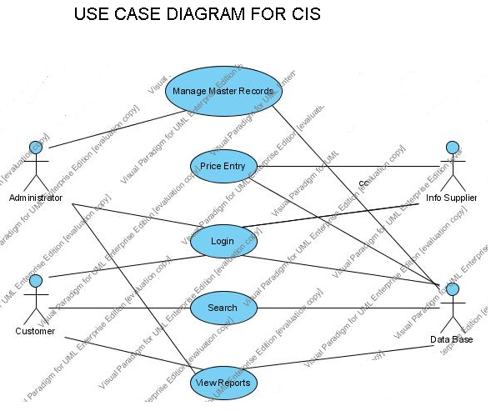

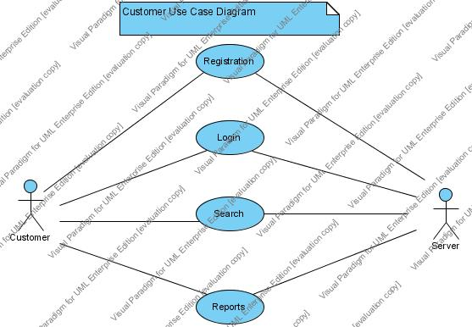

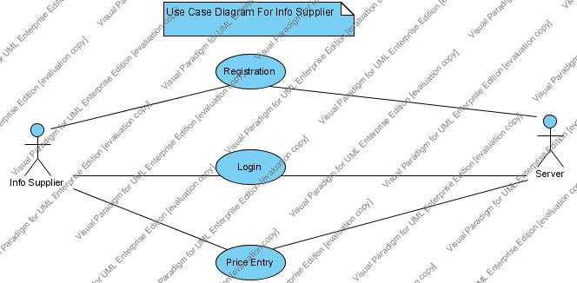

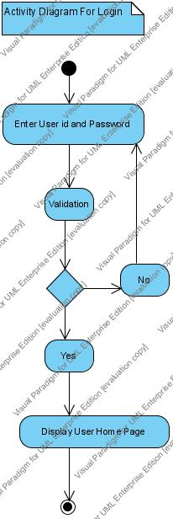

    - Data Base Designing

3.2.2.1 Table Design Document

3.2.3 Data Base Create Scripts

Create table Loc_Mast
( LocID bigint primary key, Loc_TypeID int, StateID smallint ,
DistID smallint, MandID int, VilID int,Name1 varchar(30),
Pin varchar(10) )

Create table Comm_Mast
(CommID bigint primary key,Comm_Div_TypeID int,CatID smallint ,
NameID smallint,TypeID int,GradeID int,Name1 varchar(30))

create table City_Mast
(CityID bigint primary key,Name1 varchar(50))

create table Info_Supplier
(Infosup_id int primary key,Name1 varchar(25),Dob DateTime,Addr varchar(50),
City varchar(30),Pin_Code varchar(10),Phone varchar(15),Cell varchar(20),
Fax varchar(15),Email varchar(40),Age int,Mother_Tongue varchar(15),
Occupation varchar(20),Biz_Category varchar(15),Joining_Dt DateTime,
Qualif varchar(15),Payment bigint,End_Dt DateTime)

create table Market_Mast
( MarketID int primary key,Name1 varchar(30),Address1 varchar(30),
Pin varchar(10),Amc varchar(3),Computerized varchar(3),
Phone1 varchar(20),Phone2 varchar(20),Fax1 varchar(20),Fax2 varchar(20),
Email varchar(30),LocID bigint )

create table Cust_Mast
(Cust_id bigint primary key,Name1 varchar(25),Addr varchar(50),
City varchar(20),Pin varchar(10),Phone varchar(18),Cell varchar(25),
Fax varchar(18),Email varchar(30),Mother_ton varchar(20),
DOB DateTime,Age int,Occupation varchar(25),Qualification varchar(20),
Joining_Dt DateTime,Biz_Category varchar(15))

create table UOM_Mast
(MSR_ID int not null,MSR_Name varchar(30) not null ,MSR_STAN varchar(30) not null, MSR_Value int not null,constraint PK_UOM primary key(MSR_ID,MSR_Name,MSR_STAN,MSR_Value))

create table COMM_UNIT
( MSR_ID int not null,CatID smallint)

create table Market_Comm
(CommID bigint,MarketID int,MRK_COMM_MSR varchar(20))

